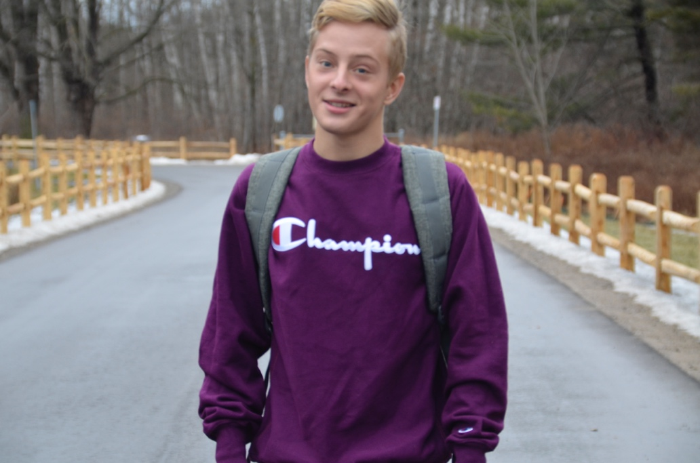Joseph Robinson is an upcoming musician from Toronto, Ontario. He has been singing and performing since the age of 8. Joseph got his start in the Younge Singers of Canada choir where he learned to collaborate with other vocalists and performed on a weekly basis at social events and church concerts. After a few years in choir, Joseph dedication led him to independent professional training and started taking vocal lessons at age 10 with the singer Dan Clancy, from the legendary and Juno winning Canadian band *Light House.* Joseph worked with Dan for 8 years and developed skills such as vocal technique, guitar playing, piano playing, music theory, music production, mixing, and more. At age 18 Joseph went on to release his first EP *Broken Souls* in 2020 which received a total of over 200,000 streams. He has released four singles since then and will be releasing new music this year. Joseph heightened his ability to market his music effectively on social media and is a known influencer. He created an image through building a TikTok page that has over 160,00 followers. He has created content for companies such as RBC (Royal Bank of Canada), Doritos, Polo, Narcity Canada, and many more. Joseph is currently working with producers and musicians in Toronto and is performing at venues all over southern Ontario with his band. He can’t wait to promote and release his new music to share with people.